
JamiHyari D. Andaya
BSIT-4A

Enterprise Server Deployment and Operating System Installation Installation Guide
- Project Overview
This documentation outlines the end-to-end setup of Ubuntu Server and Windows Server environments within VirtualBox, simulating a Junior System Administrator role. Key tasks included building virtual machines, configuring core network settings, securing remote access via SSH, and updating system packages to support future enterprise services like database hosting, web applications, and file sharing. The report concludes with a technical comparison of BIOS/UEFI firmware and leading enterprise server OS platforms.

Objectives
The objectives of this project were to:
- Install Ubuntu Server in a virtual machine.
- Configure the hostname, user account, storage, network, and keyboard settings.
- Install and verify the OpenSSH Server service.
- Verify the server hostname, IP address, and internet connectivity.
- Update the Ubuntu Server operating system.
- Install and configure Windows Server Evaluation.
- Compare BIOS and UEFI firmware.
- Illustrate the Ubuntu boot process.
- Compare Windows Server, Ubuntu Server, and Rocky Linux.
- Produce clear technical documentation for future administrators.

Software Requirements
The following software and installation media were used:
- Oracle VirtualBox 7.2
- Ubuntu Server 24.04.4 LTS ISO
- Windows Server 2022 Evaluation ISO

- Microsoft Word
- Draw.io or an equivalent diagramming tool

Ubuntu Server Virtual Machine Specifications

Component | Configuration
Virtual Machine Name | Ubuntu-Server-Week03
Operating System | Ubuntu 64-bit
Memory | 4096 MB
Processors | 2 virtual processors
Virtual Storage | 40 GB VDI
Network | NAT
Installation Media | Ubuntu Server 24.04.4 LTS AMD64 ISO
Hostname | server01
Administrative Username | nico

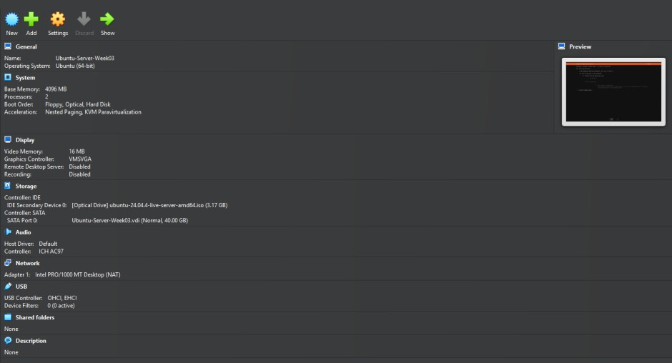
Figure 1. Oracle VirtualBox specifications for the Ubuntu Server virtual machine.

Ubuntu Server Installation Procedure
  - Starting the Installer
The Ubuntu Server ISO was mounted to the virtual optical drive prior to powering on the VM. From the boot screen, the Try or Install Ubuntu Server option was selected, with

English set as the system language and English (US) chosen for the keyboard layout. The installer's update prompt was intentionally bypassed to allow package updates to be executed and documented manually during the post-installation verification phase.

Network Configuration
Network connectivity was established using VirtualBox’s default Network Address Translation (NAT) mode, with the Ubuntu installer automatically receiving an IP address via DHCP. Because the VM utilized a single network interface, network bonding was unnecessary. The proxy configuration was skipped as none was required for the environment, and the default Ubuntu archive mirror was kept for package downloads.

Storage Configuration
Guided storage configuration was selected using the entire 40 GB virtual disk. Logical Volume Management was enabled using the default settings. Disk encryption was not enabled because it was not required for the laboratory activity. Ubuntu created a BIOS boot partition, an ext4 /boot partition, and an LVM logical volume formatted as ext4 and mounted at /.
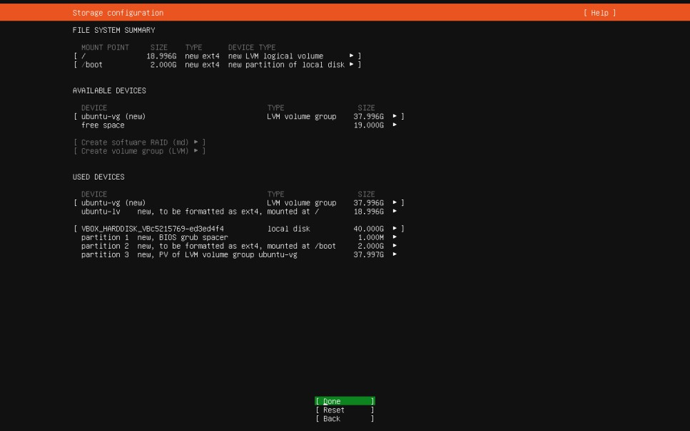
Figure 2. Ubuntu Server storage configuration showing the partitions, LVM volume, and ext4 file system

User and Hostname Configuration
During profile setup, a non-root administrative account was created using nico as the username alongside the system hostname server01. A secure password was defined for both local authentication and elevated privileges via sudo.

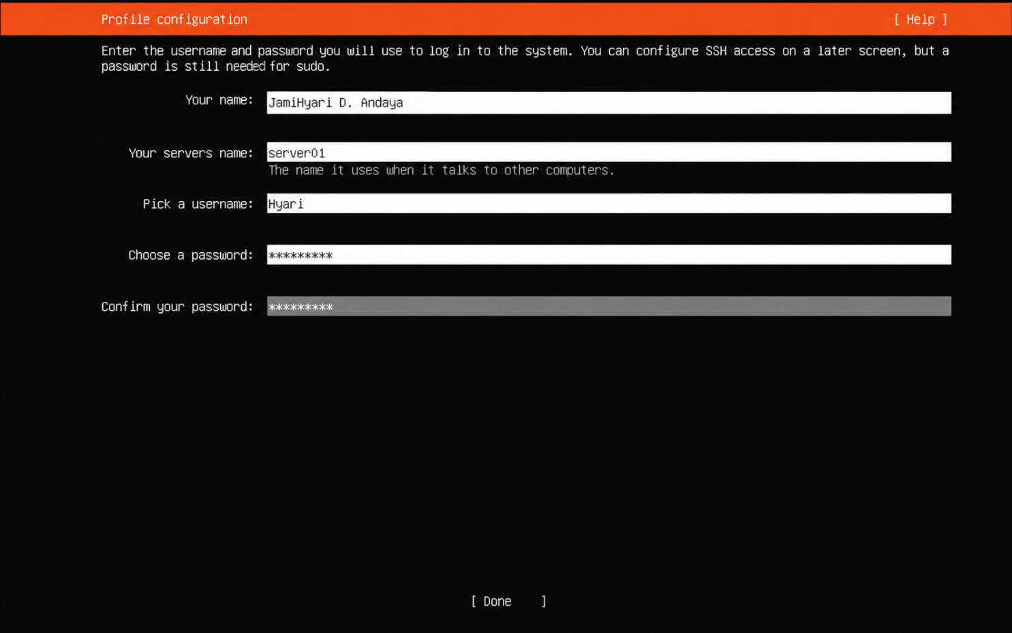

Figure 3. Ubuntu Server profile configuration showing the server hostname and administrative user.

Additional Configuration
Ubuntu Pro was skipped because it was not required for the activity. No featured server snaps were installed because the instructions required a clean server installation without unnecessary additional packages.
The installer then copied and configured the required operating-system files

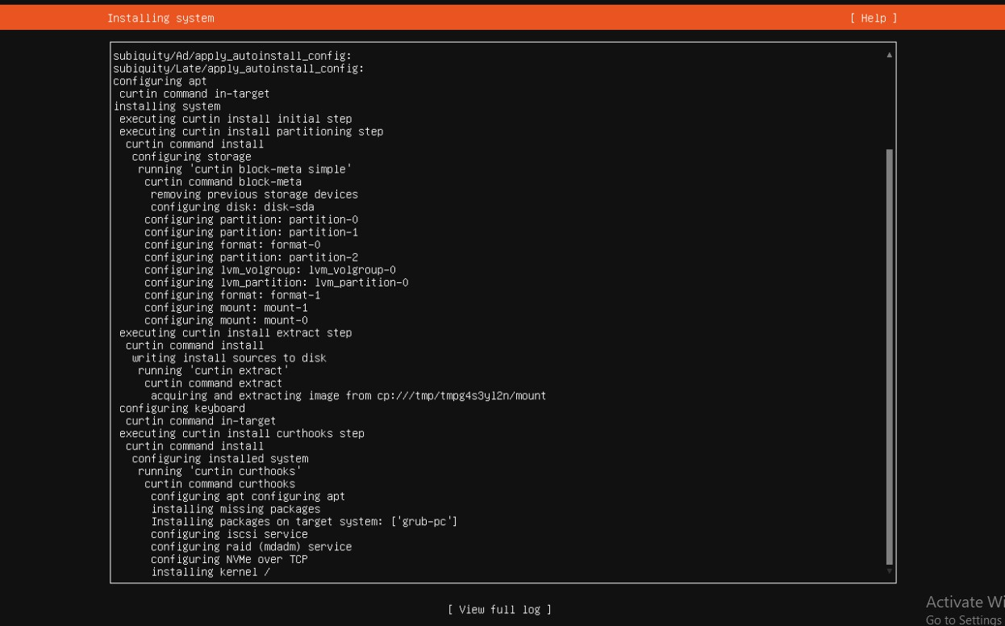
Figure 4. Ubuntu Server installation progress

Completing the Installation
After completing the installation, the ISO image was unmounted from the virtual optical drive. The VM was then rebooted to boot directly into the newly installed operating system on the virtual hard disk.

Ubuntu Server Verification
  - Successful Login
After rebooting, the administrative user logged in using the account created during installation. The prompt nico@server01 confirmed the username and configured server hostname.


Figure 5. Successful login to Ubuntu Server using the non-root administrative account

Hostname Verification
The following command was used:
    - Hostname
The command returned:
    - Server01
This confirmed that the hostname was configured correctly.



Figure 6. Verification of the Ubuntu Server hostname

IP Address Verification
The assigned network address was checked using:
    - ip addr
The enp0s3 network interface displayed the IPv4 address 10.0.2.15/24. The interface also showed an active state, confirming that the VirtualBox network adapter was functioning.

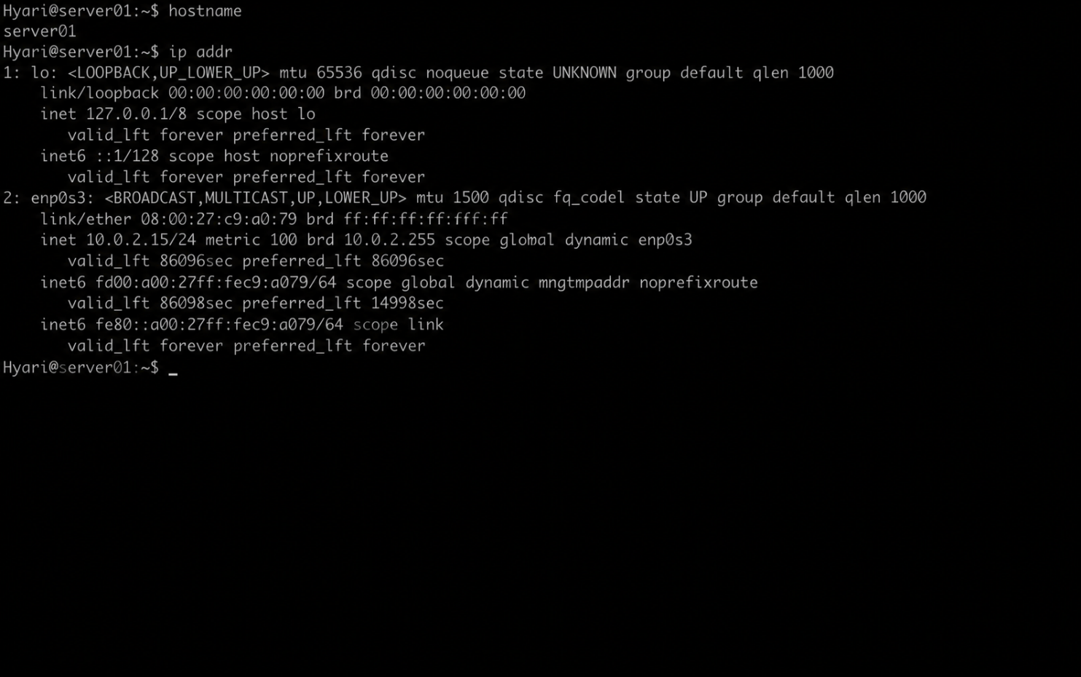

Figure 7. Network interface and DHCP-assigned IP address of Ubuntu Server

Internet Connectivity Test
Internet and Domain Name System connectivity were tested using:
    - ping -c 4 google.com
The server successfully received four responses, confirming that it could resolve the domain name and communicate through the internet.

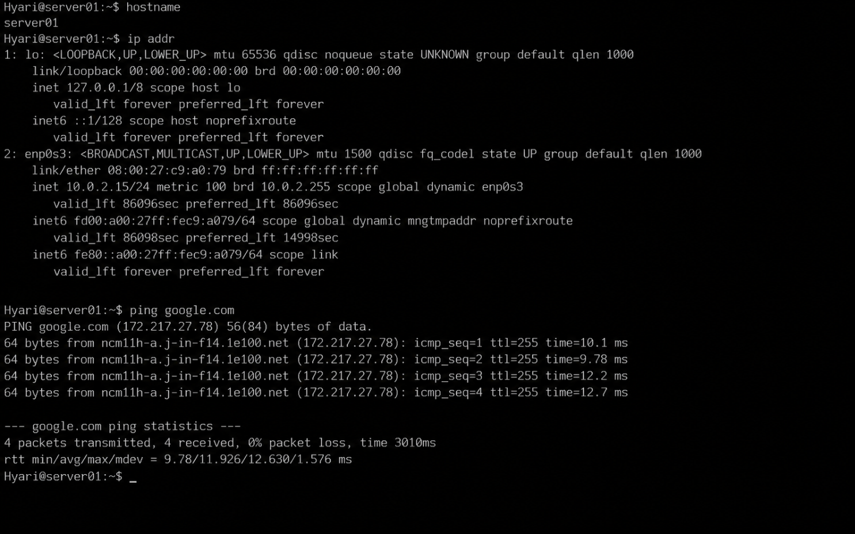

Figure 8. Successful internet connectivity test using the ping command.

System Update
The server’s package information and installed packages were updated using:
    - sudo apt update
    - sudo apt upgrade –y
The first command retrieved the latest package information from the configured Ubuntu repositories. The second command installed available package and security updates.

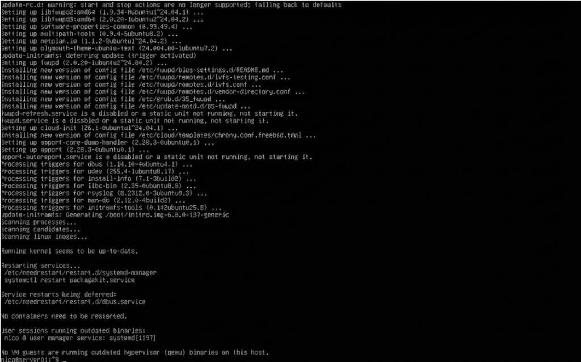
Figure 9. Ubuntu Server package and security update process.

OpenSSH Server Verification
OpenSSH Server was installed using:
    - sudo apt install openssh-server –y
The service was started and verified using:
    - The service was started and verified using:
    - sudo service ssh status
The status displayed active (running), confirming that the server was ready for secure remote administration.

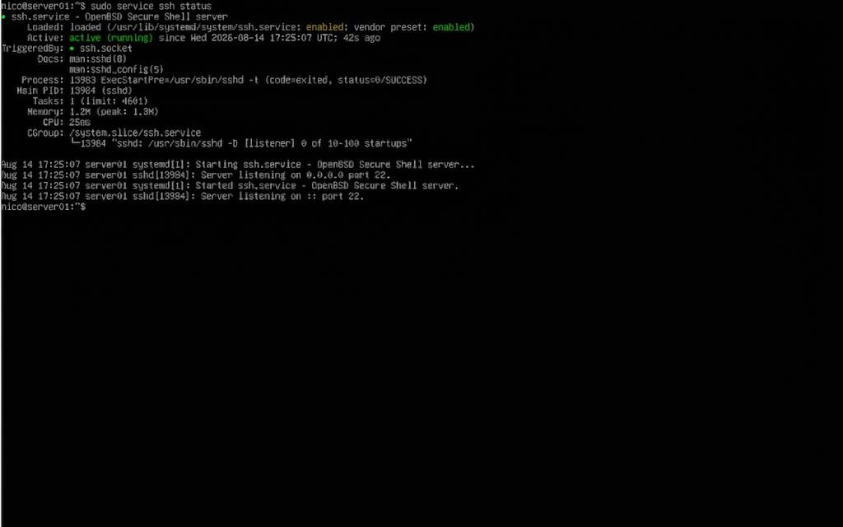
Figure 10. OpenSSH Server service showing an active and running status.

BIOS and UEFI Comparison

Category | BIOS | UEFI
Definition | Traditional firmware used to initialize hardware and begin loading an operating system. | Modern firmware interface connecting the operating system with the platform  firmware.
Boot Process | Traditional firmware used to initialize hardware and begin loading an  operating system. | Loads the operating-system bootloader from the EFI System  Partition.
Disk Support | Traditional firmware used to initialize hardware and begin loading an  operating system. | GPT supports disks significantly larger than 2 TB.
Partition Style | Master Boot Record. | GUID Partition Table.
Security | Provides limited boot verification. | Supports Secure Boot and  signed boot components.
Speed | Generally slower during  initialization. | Can provide faster startup and  hardware initialization.
Advantages | Simple and compatible with older systems. | Supports large disks, additional partitions, modern security, and flexible firmware  management.

Disadvantages | Limited storage, partitions, security, and extensibility. | Can be more complicated and may not support older  operating systems.
Modern Usage | Mainly used by legacy computers. | Standard firmware for modern  computers and servers.

Due to its superior suitability for contemporary storage, UEFI has largely supplanted BIOS. Hardware, operating systems, and security specifications. It makes use of GPT to enable larger more partitions and storage devices than a conventional MBR. UEFI Secure Boot is capable of additionally check boot components before letting them run, lowering the possibility of unapproved software that runs at startup. Because of these features, UEFI is more. Secure and scalable for contemporary enterprise deployments
The complete comparison and one-page discussion are provided separately in BIOS_vs_UEFI.pdf.

Ubuntu Boot Process
The Ubuntu Server boot process consists of eight major stages:
- Power On
- BIOS/UEFI Initialization
- Boot Device Detection
- Boot Loader (GRUB)
- Linux Kernel
- Init/systemd
- Services Start
- Login Prompt
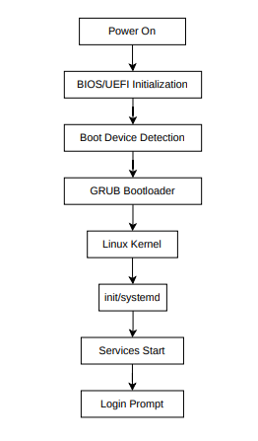
Figure 11. Ubuntu Server boot-process flowchart.

During startup, the firmware initializes the virtual hardware and detects the bootable storage device. GRUB then loads the Linux kernel. The kernel initializes memory, processors, and device drivers before starting systemd. Systemd starts networking, SSH, and other required services before displaying the login prompt.

G.Windows Server Installation
  - Virtual Machine Configuration
A separate virtual machine was created for Windows Server to avoid modifying the completed Ubuntu Server installation.

Component | Configuration
Virtual Machine Name | Windows-ServerWeek03
Operating System | Windows Server 2022 Evaluation
Memory | 4096 MB
Processors | 2 virtual processors
Virtual Storage | 50 GB
Network | NAT
Computer Name | SERVER02
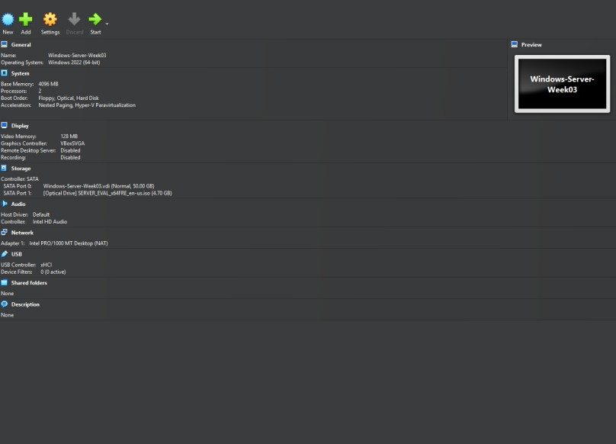
Figure 12. Oracle VirtualBox specifications for the Windows Server virtual machine.

Edition Selection
Windows Server 2022 Standard Evaluation with Desktop Experience was selected. Desktop Experience was used because it provides a graphical interface and Server Manager
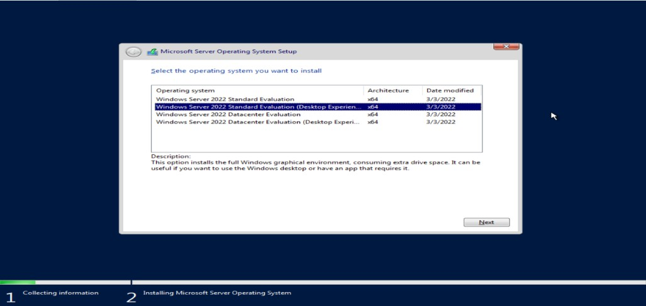
Figure 13. Selection of Windows Server 2022 with Desktop Experience.

Disk and Installation
A custom installation was performed using Drive 0 Unallocated Space. Windows Setup automatically created the necessary system partitions and installed the operating system on the virtual disk.

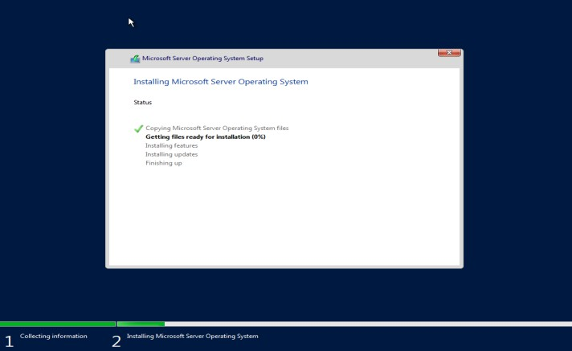
Figure 14. Windows Server installation progress.

Administrator Configuration
After installation, a password was configured for the built-in Administrator account. The password provided administrative access to Windows Server and was kept hidden in the documentation.
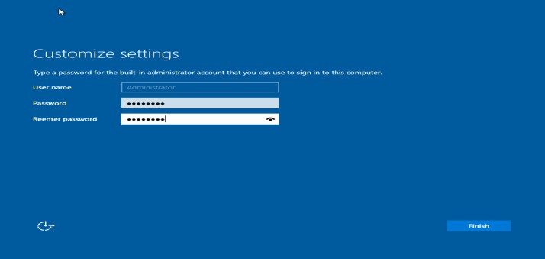
Figure 15. Administrator account password configuration.

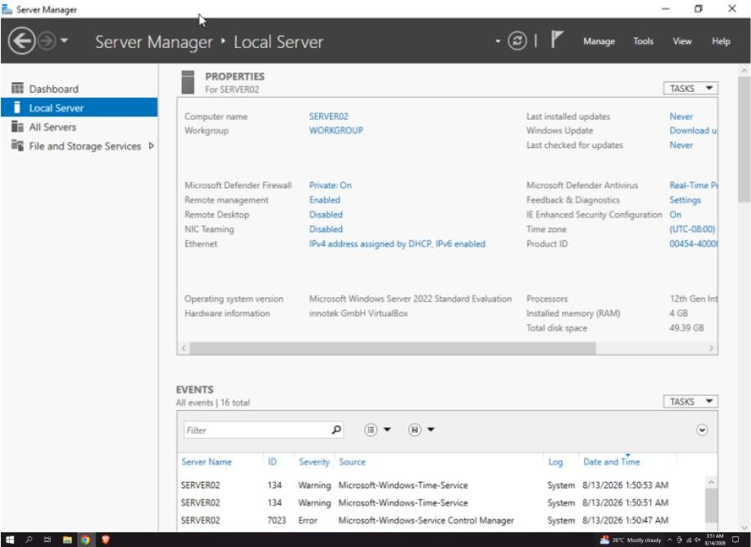
Figure 16. Successful Windows Server login and verification of the SERVER02 computer name.

Enterprise Operating System Comparison

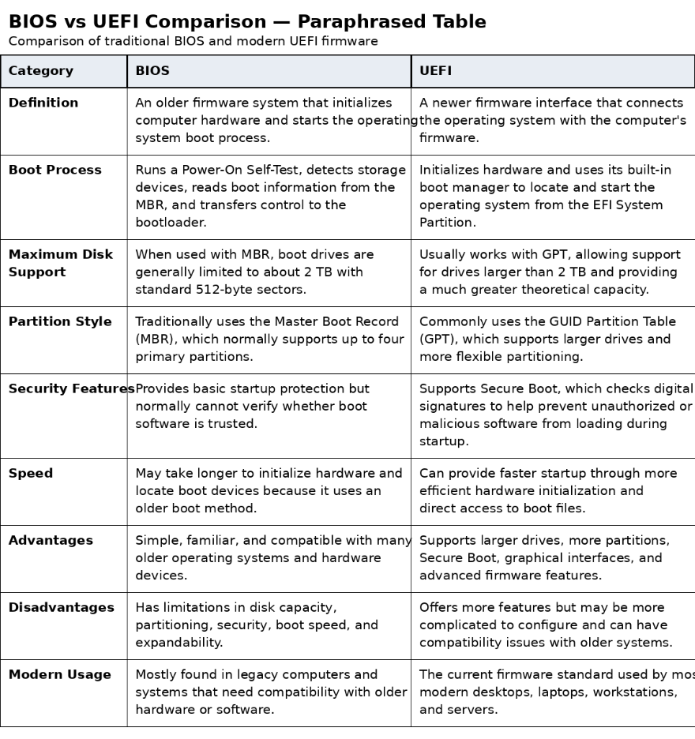
Windows Server is a good choice for organizations that rely heavily on Microsoft Technologies and centralized domain technologies. Ubuntu Server is well-suited for cloud environments, web hosting, containerized applications, and open-source software. Rocky Linux is a suitable option for businesses that prioritize stability and compatibility with the Red Hat Enterprise Linux ecosystem.
The complete discussion is provided separately in OS_Comparison_Report.pdf.

Problems Encountered and Solutions Implemented
  - Incorrect Ubuntu ISO
The first downloaded ISO was Ubuntu Desktop rather than Ubuntu Server. Although both editions were labeled Ubuntu 24.04.4 LTS, the filename contained desktopamd64.
Solution: The correct ubuntu-24.04.4-live-server-amd64.iso file was downloaded and attached to the Ubuntu Server virtual machine.

Installation Media Could Not Be Unmounted
After Ubuntu installation, the system displayed a message stating that it failed to unmount
/cdrom and requested removal of the installation media. Solution: The ISO was removed

from the VirtualBox optical drive, and the virtual machine was allowed to reboot from the installed virtual hard disk.

OpenSSH Service Was Not Found
The command used to verify SSH initially reported that ssh.service could not be found. This indicated that OpenSSH Server had not been installed during the installation wizard.
Solution: OpenSSH Server was installed manually using sudo apt install opensshserver -y. The service was then started and verified as active and running.

Incorrect Command Typing
The systemctl command was initially entered incorrectly, preventing the SSH service status from being displayed. Solution: The correct command syntax was reviewed. The equivalent service ssh status command was then used to verify the service successfully.

Lessons Learned
Through this activity, I gained hands-on experience installing and configuring two enterprise server operating systems. I recognized the importance of selecting the right ISO edition, as desktop and server variants from the same LTS release differ significantly in user interfaces and default packages. Additionally, I learned how adjusting virtual machine resources—such as CPU, RAM, storage, network modes, and installation media—directly impacts server performance.
Executing verification commands in Ubuntu highlighted how administrators confirm network settings, hostnames, internet connection, system updates, and active services post-installation. Troubleshooting a missing SSH service reinforced the value of precision when typing terminal commands, reading error outputs, and applying post-deployment fixes. Finally, setting up Windows Server expanded my skills in navigating GUI-based server environments, configuring Administrator credentials, and establishing proper system naming. Ultimately, this exercise strengthened my foundation in server deployment, virtualization, remote management, and documentation, preparing me for advanced tasks like web hosting, database management, and network administration.

References
Canonical. (n.d.). Get Ubuntu Server https://ubuntu.com/download/server Canonical. (n.d.). Ubuntu Server documentation https://ubuntu.com/server/docs/

Canonical. (n.d.). Ubuntu 24.04 LTS release notes. https://documentation.ubuntu.com/release-notes/24.04/ Microsoft. (n.d.). Windows Server 2022 Evaluation.
https://www.microsoft.com/en-us/evalcenter/evaluate-windows-server-2022 Microsoft. (n.d.). Windows Server documentation. https://learn.microsoft.com/en-us/windows-server/
Rocky Linux. (n.d.). Rocky Linux documentation. https://docs.rockylinux.org/
Unified EFI Forum. (n.d.). UEFI specifications. https://uefi.org/specifications

